### **Multi-Branch Project**

#### **Project Overview**

* Create a simple Java Maven project.
* Version-control the project using Git with multiple branches.
* Set up Jenkins multi-branch pipeline for automated build and deployment.
* Utilize Jenkins environment variables in the Jenkinsfile.

#### **Project Objectives**

* Version-control using Git.
* Jenkins multi-branch pipeline setup.
* Environment variable management using Jenkinsfile.

#### **Project Deliverables**

1. **Git Repository:**
   * Local Git repository initialized.
   * Branches: development, staging, and production.
   * Repository pushed to remote Git server (e.g., GitHub, GitLab, Bitbucket).

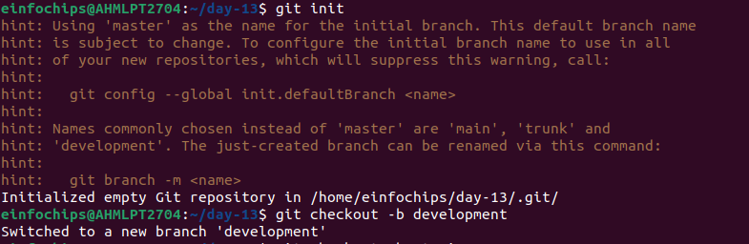

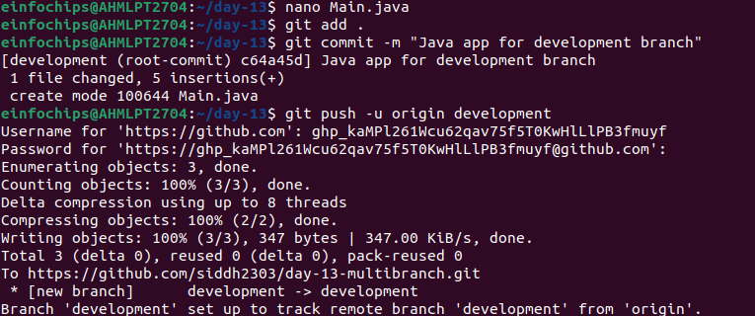

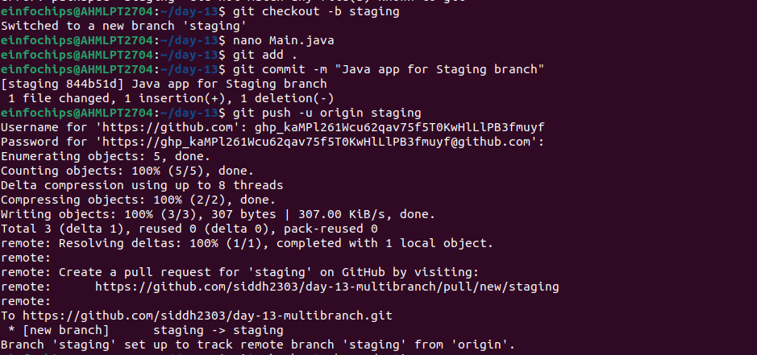

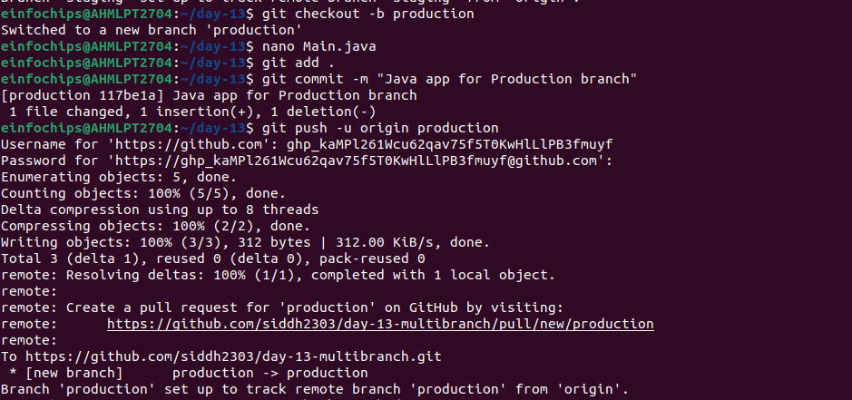

**Main.java:**

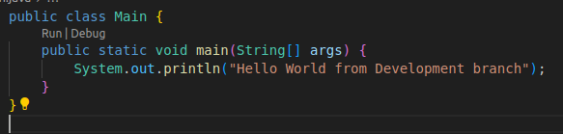

1. **Jenkins Setup:**
   * Multi-branch pipeline job configured in Jenkins.
   * Jenkinsfile defining build and deployment steps.
   * Environment variables managed using Jenkins environment variable settings.

**Jenkinsfile:**

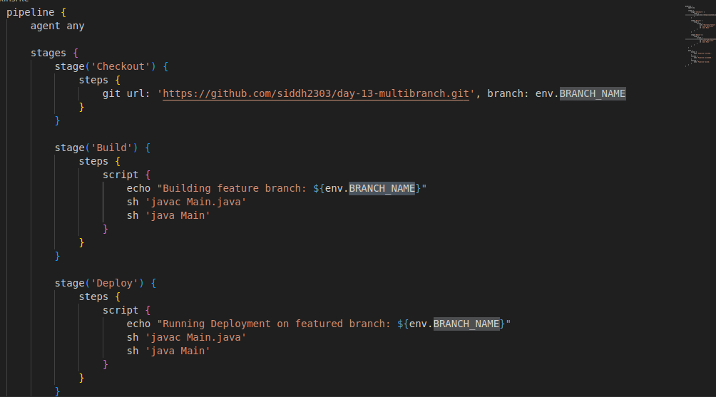**To create environment variable inside Jenkins:**

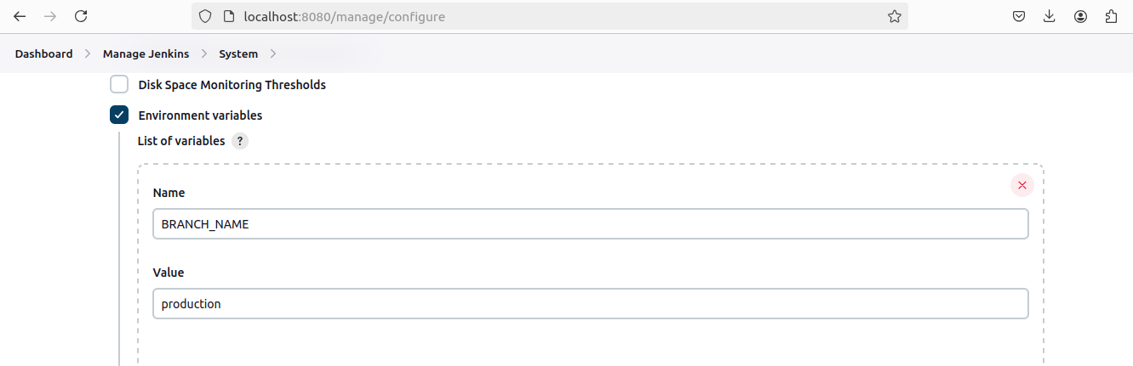**Create a Jenkins project having type Multibranch Pipeline**

**Add git repository:**

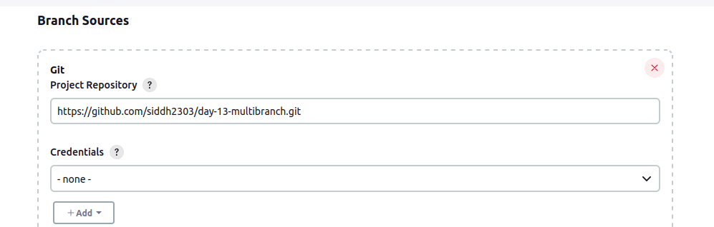**Build-1 Development branch:**

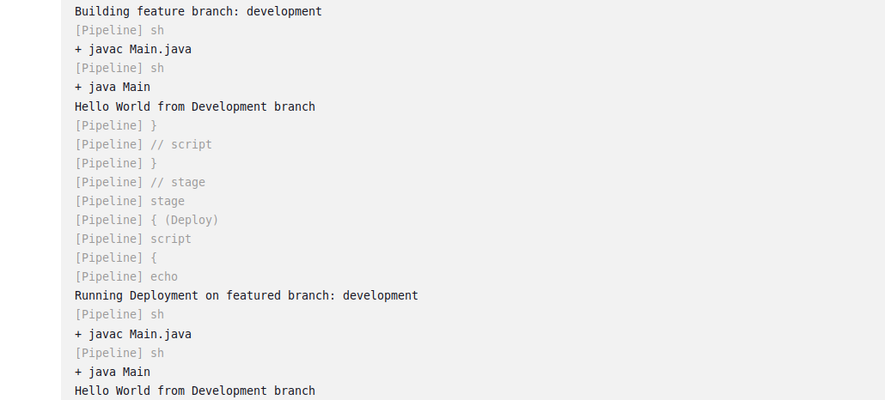**Build-2 Staging:**

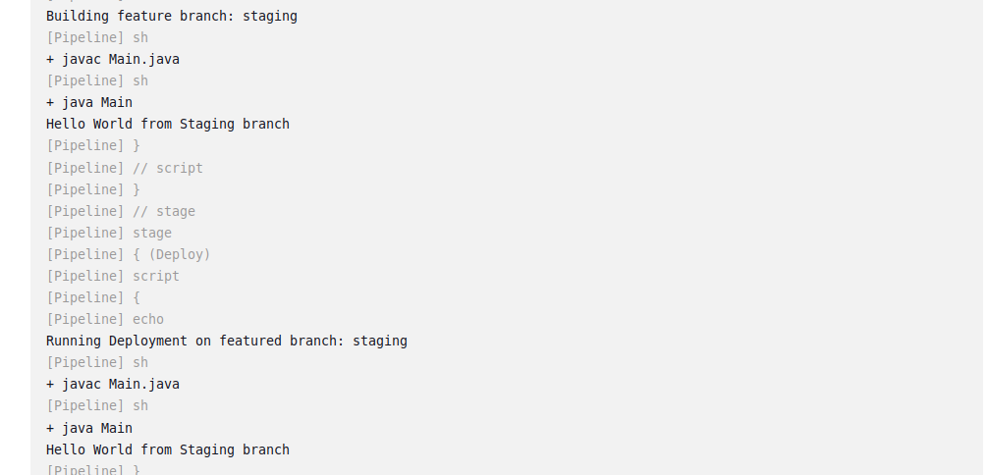**Build-3 Production:**

